A Recipe For:

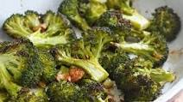 

# **Roasted Broccoli With Smashed Garlic**

**From the Kitchen of:** Mom

**Servings:** 4

**Prep Time:** 5 minutes **Bake Time:** 20 minutes **Bake Temp: 450**

**Ingredients:**

* 1 ½ lbs. broccoli florets, cut long with part of stem
* 6 cloves garlic, smashed
* 2 Tbsp extra virgin olive oil
* Kosher salt and fresh pepper

**Instructions:**

1. Preheat oven to 450
2. In a baking dish, combine broccoli, olive oil, garlic, salt and pepper.
3. Roast broccoli about 20 minutes, until broccoli is browned and tender.